User Manual
PURE2GOTM WATER PURIFIER TRAVEL KIT
Model Number P2GT-300
Patents Pending

Copyright 2016 Water One of Southwest FL



TO SAFE WATER
Kills Bacteria & Viruses and Eliminates Cysts

Thank you for choosing the Pure2GoTM Water Purifier Travel Kit, containing the best and most reliable personal and multiuser water purifier on the market. A true water purifier, Pure2GoTM has been independently tested and proven to transform contaminated water into microbiologically safe drinking water eliminating 99.997% of waterborne cysts as well as killing 99.9999% of waterborne bacteria, and 99.997% of waterborne viruses.
Pure2GoTM eliminates the need to carry or locate safe drinking when traveling, hiking, or in an emergency situation. When traveling to areas that may not have safe water, don’t leave home without it!

Limited Warranty
Your Pure2GoTM Water Purifier is warranted for two (2) years from the date of purchase against defects in materials or workmanship when used in accordance with manufacturer’s instructions. Please keep your proof of purchase. If there are any defects, return the unit, postage prepaid, with proof of purchase to Water One of SW FL, 4840 Laredo Avenue, Fort Myers, Florida 33905. Phone: 239-425-6100.

This guarantee does not cover improper use, damage caused by user, premature clogging from highly turbid water, damage related to use with salt water or other liquids, normal wear and tear or the maintenance or replacement of used insert cartridges.
Precautionary Statements
Do Not Use Pure2GoTM With Salt Water. Use only with both, certified Pure2GoTM insert cartridges WOUF-300 and WOVBC-300 in place. The upper cartridge contains iodinated resin and granulated activated carbon. Persons with iodine allergies or thyroid problems and pregnant women should consult their doctor before using this device as minute amounts of iodine (< 1ppm) may remain in the purified water. Supervision required for children’s use.
WARNING: microbiological hazard


Hazards are associated with use of water purifiers. Drinking untreated water may expose you to harmful microorganisms and increase your risk of gastrointestinal illness. Improper use of this purifier increases your risk of exposure to harmful microorganisms and increases your risk of gastrointestinal illness. Reduce your chances of becoming sick by following the precautionary statements and instructions in this manual. Never use the Pure2GoTM water purifier with salt water or chemically contaminated water, such as from mine tailing ponds or agricultural collection ponds. Never use Pure2GoTM with any other brand of insert cartridges. Use only with WOUF-300 and WOVBC-300 sold by Water One of Southwest Florida. Read understand and follow all instructions and warnings in this user manual.

Pure2Go-TM Traveler’s Kit
Key Component Parts

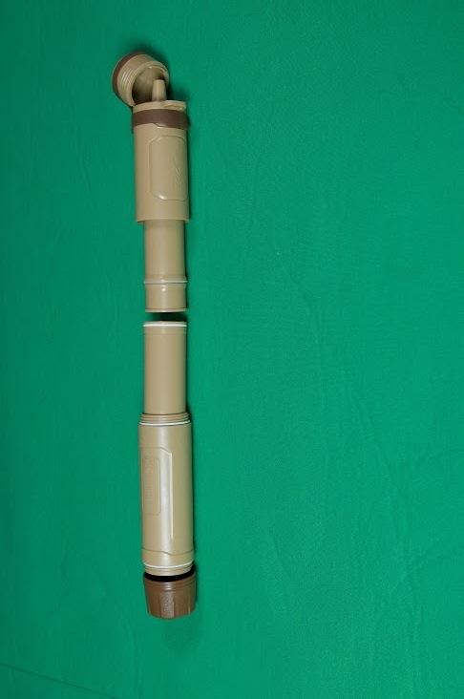
Cap

Clean Water Mouthpiece
(outflow port)

Hook for Lanyard

Cap Band

Upper Threaded Housing

Upper housing replaceable insert cartridge, model # WOVBC-300

Lower housing replaceable insert cartridge model # WOUF-300

Lower threaded housing

Dual threaded bottom intake cap with 28mm threaded fitting and nipple fitting

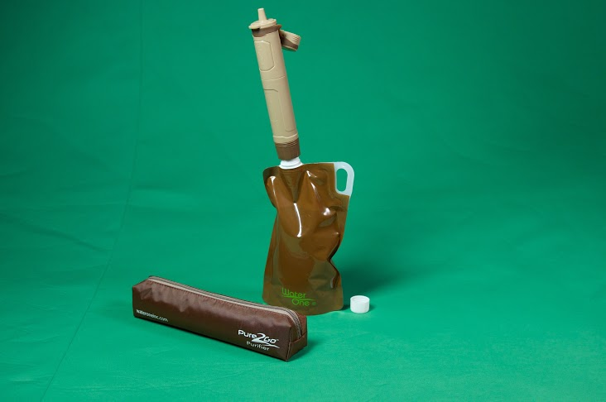
Collapsible Bottle for use with source water

Travel Kit Pouch
Directions For Use

The Pure2GoTM purifier is unique because it has two cleanable, reusable and replaceable cartridges and can be used like a drinking straw and with Pure2GoTM accessories such as the collapsible source water bag included in the P2GTM Traveler’s Kit.

Drink directly from Water Source
Sip as a straw directly from the source water
Step 1: Open the cap of the P2GTM. Using a gentle tug pull downwards on the cap allowing the cap band to hold the cap out of the way of the mouthpiece.
Step 2: Put the dark brown intake end of the P2GTM directly into the source water or a container, such as a glass, filled with source water.
Step 3: Put the mouth over the mouthpiece/clean water port and suck on the P2GTM like a straw. Water from the source will be purified as it is drawn upward by suction through the P2GTM, passing through the UF filter in the lower housing and the ViroBacTM & Granulated Activated Carbon in the upper housing. * When using the P2GTM for the first time or after changing the upper housing insert filter your first few mouthfuls of water will be dark in color as it contains carbon fines from the new GAC filter media. There is no danger from this carbon but we recommend expelling the first mouthfuls of water until it is clear.
Step 4: When finished drinking, close the cap on the P2GTM

Drink as a straw drinking from the source collapsible bottle
Step 1: Take off the cap of the source water collapsible bottle and fill it with source water.
Step 2: While holding the open source water collapsible bottle in an upright position screw the threaded opening of the collapsible bottle into the threaded intake end of the P2G^{TM.}
Step 3: Open the cap of the P2GTM. Using a gentle tug pull downwards on the cap allowing the cap band to hold the cap out of the way of the mouthpiece.
Step 4: Put the mouth over the mouthpiece/clean water port and suck on the P2GTM like a straw.
Step 5: When finished drinking, close the cap on the P2GTM , detach collapsible bag from P2GTM and replace cap on collapsible bottle.

Squeeze or gravity flow clean water from collapsible bag
Step 1: Take off the cap of the source water collapsible bottle and fill it with source water.
Step 2: While holding the open source water collapsible bottle in an upright position screw the threaded opening of the collapsible bottle into the threaded intake end of the P2G^{TM.}
Step 3: Open the cap of the P2GTM. Using a gentle tug pull downwards on the cap allowing the cap band to hold the cap out of the way of the mouthpiece.
Step 4: For squeezing water from the collapsible bottle, hold collapsible bottle in one hand and P2GTM in the other hand. Tip collapsible bottle and P2GTM at least 90 degrees such that the mouthpiece/clean water port is tilted over clean drinking glass or other receptacle. Begin squeezing the back end of the collapsible bottle gently forcing water to flow through the P2GTM and out the mouthpiece/clean water port into the clean receptacle.
Step 5: When the desired amount of water has been put into the clean water receptacle, return P2GTM and collapsible bottle to an upright position. Close the cap on the P2GTM, detach collapsible bag from P2GTM and replace cap on collapsible bottle.

When finished with the P2G and/or collapsible bottle they can be returned to the Travel Kit Pouch for storage.



Drink From the Collapsible Bottle



Drink from Questionable water using as a straw

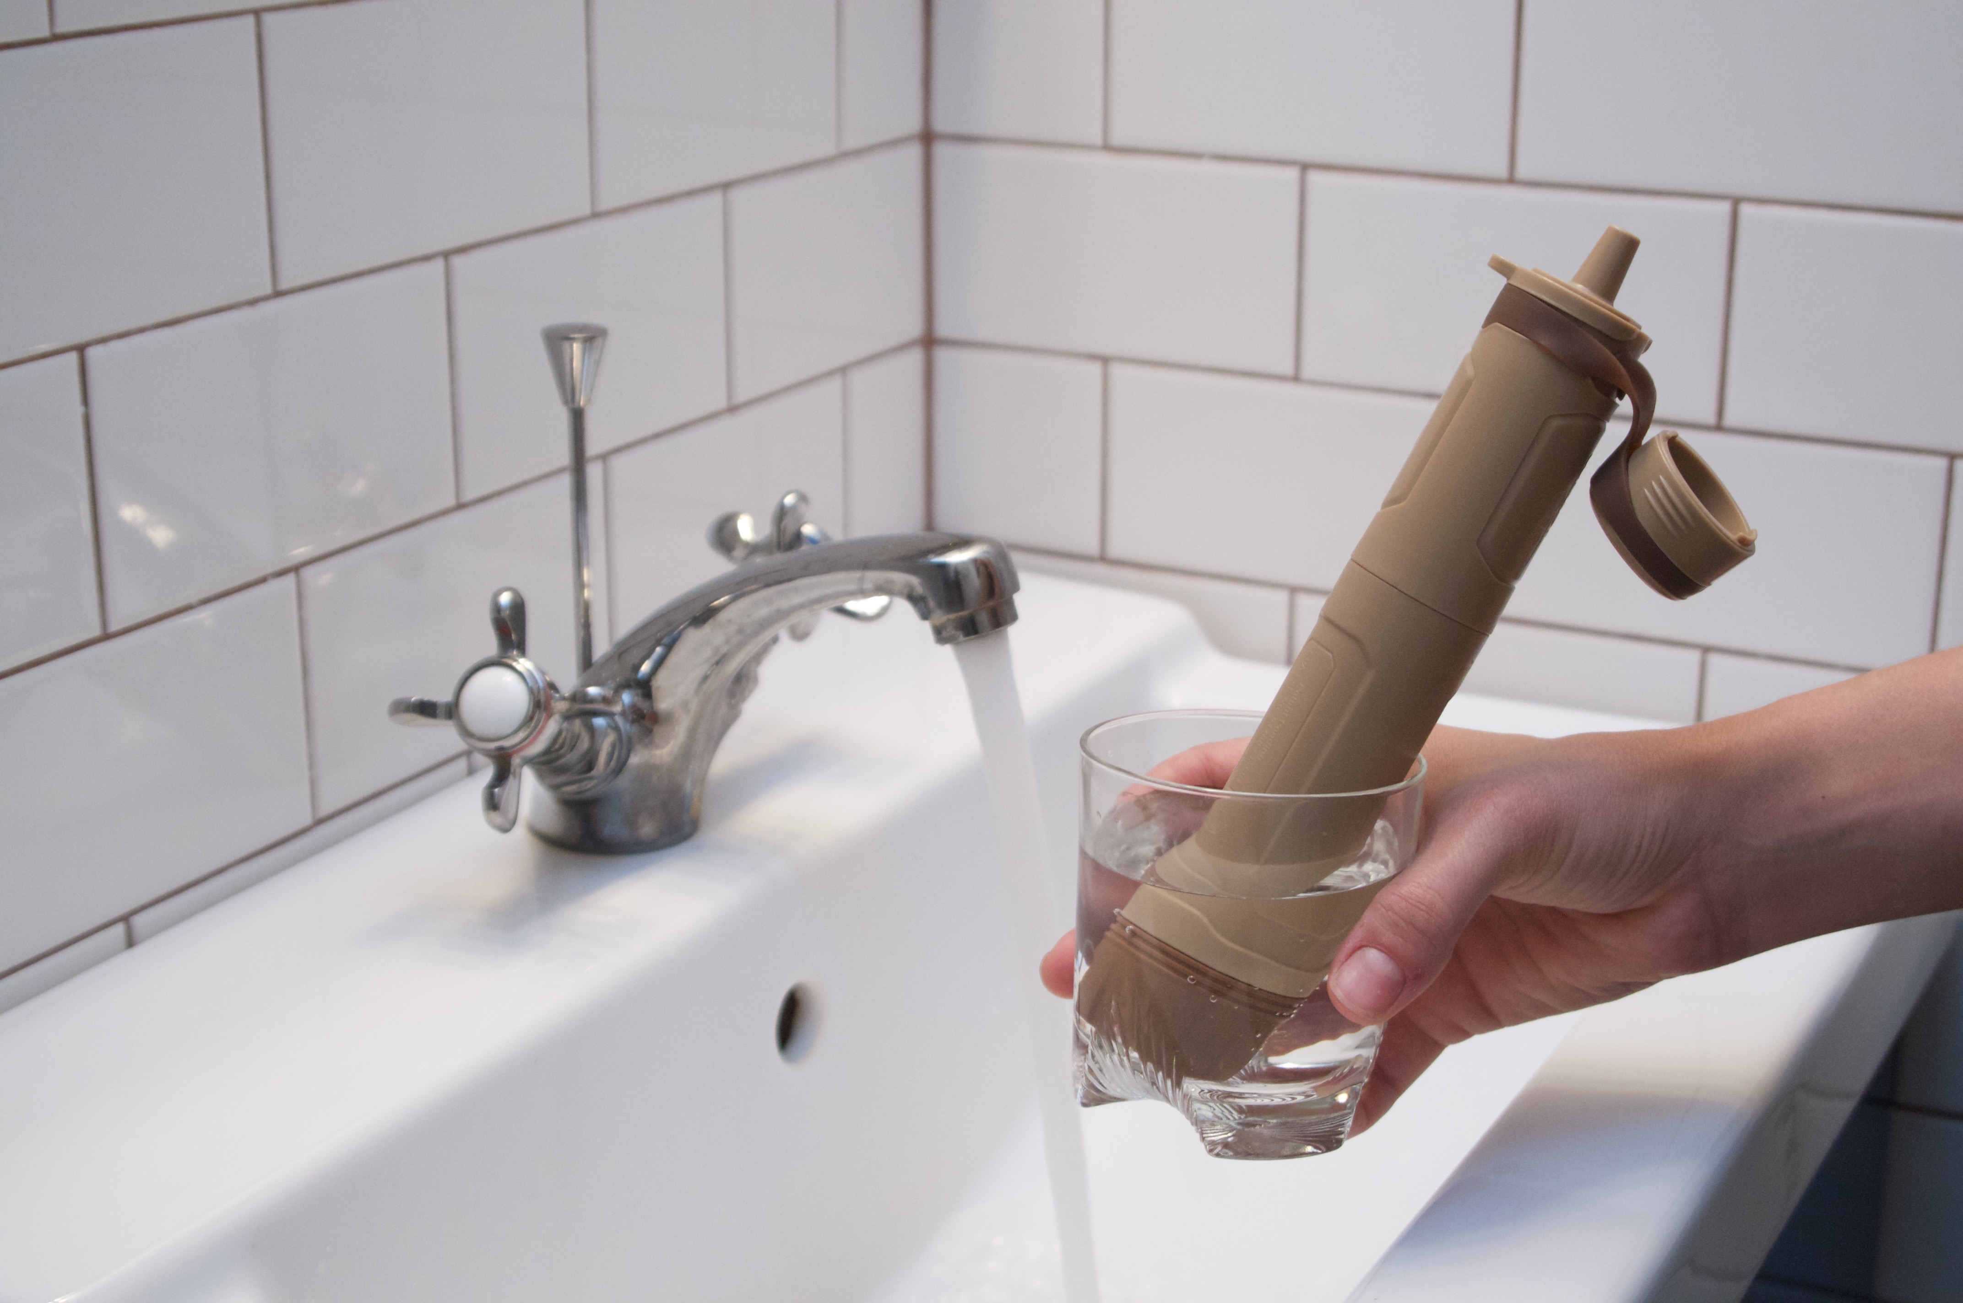

CLEANING & MAINTENANCE

DAILY CLEANING: After each use or daily when using, we recommend to clean the P2GTM.

Step 1: Unscrew bottom intake cap and set aside.
Step 2: Open the cap of the P2GTM. Using a gentle tug pull downwards on the cap allowing the cap band to hold the cap out of the way of the mouthpiece.
Step 3: Place mouth on mouthpiece and blow air down through the P2GTM to loosen and expel sediment along with water remaining in the P2GTM..
Step 4: Close cap on P2GTM, screw bottom intake cap onto P2GTM, wipe dry and store P2GTM in travel pouch.

CLEANING & STORING: We recommend to clean the P2GTM thoroughly before storing between trips.

Step 1: Unscrew bottom intake cap and set aside.
Step 2: Open the cap of the P2GTM. Using a gentle tug pull downwards on the cap allowing the cap band to hold the cap out of the way of the mouthpiece.
Step 3: Close cap on P2GTM, screw bottom intake cap onto P2GTM, thoroughly wipe dry and store P2GTM in travel pouch.

CLEANING COLLAPSIBLE BOTTLE: We recommend cleaning the collapsible source water bag to for storing between trips. Preventing the growth of bacteria in the bag during storage is easy to do with a simple disinfection procedure.

Step 1: Unscrew cap from collapsible bottle and set aside. Using clean safe water from a tap if possible, fill up collapsible bottle, replace cap, shake vigorously, unscrew cap and pour out water.
Step 2: Fill collapsible bottle again with safe clean water if possible, add two drops of household bleach. Close the cap and shake vigorously.
Step 3: Let bottle stand with cap on for three minutes, then open cap and pour out the water and bleach solution. Fill again with tap water, rinse and pour out, repeat once more.
Step 4: Wipe dry both cap and collapsible bottle then air dry with cap off before placing in travel pouch with P2GTM and storing.

User manual and other instruction videos are available online at: www.pure2gopurifier.com

REPLACEABLE INSERT CARTRIDGES
Your Pure2GoTM has been designed to last a lifetime with replaceable cartridges that should be changed every two years or after 300 US gallons (1135 liters) whichever comes first. Both the UF cartridge (model# WOUF-300) and the ViroBacTM & GAC cartridge (model# WOVBC-300) can be ordered directly from Water One of Southwest Florida, Inc. by calling: +1 239.425.6100 or contacting us at info@wateroneinc.com

REPLACING P2GTM INSERT CARTRIDGES
Step 1: Unscrew the upper threaded housing from the lower threaded housing at approximately the midpoint of the P2G^{TM.}
Step 2: Holding the upper threaded housing in one hand, grasp the exposed end of the upper housing, insert cartridge. Pull gently downward and the insert cartridge (model# WOVBC-300) will come free from the upper housing. Dispose of used insert cartridge in trash.
Step 3: Insert a new WOVBC-300 ViroBacTM & GAC insert cartridge into the upper housing in the same orientation as the cartridge removed, pushing on the end of the insert cartridge until it comes to the stop point.
Step 4: Holding the lower housing in one hand, unscrew the dark brown threaded intake cap from the lower housing.
Step 5: From the bottom of the lower housing, push the WOUF-300 insert cartridge upwards and out of the lower housing at its top end.
Step 6: Insert a new WOUF-300 Ultrafiltration insert cartridge into the lower cartridge from the top end of the lower cartridge in the same orientation as the cartridge removed, pushing the end of the insert cartridge into the lower housing until it comes to the stop point.
Step 7: Reattach the threaded intake cap to the bottom of the lower housing.
NOTE: The insert cartridges for both the upper and lower housings can only go in one way. See illustrations below.

When the new replacement inserts have been inserted into both housings and the housings have been screwed by together your P2G is ready to use again for another two years or 300 US Gallons (1135 liters).
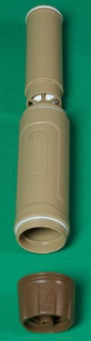

WOUF-300 lower housing replaceable cartridge

Lower Housing

Lower housing threaded cap

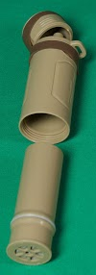

Upper Housing

WOVBF-300 upper housing replaceable cartridge

